

This is a pentagon because it has five sides and five corners.

This is a regular pentagon because it has five edges of equal length and all angles are the same size.



[](https://www.google.co.uk/url?sa=i&rct=j&q=&esrc=s&source=images&cd=&cad=rja&uact=8&ved=2ahUKEwjyp5qf9pLhAhVQlxoKHUgvAoAQjRx6BAgBEAU&url=https://www.flickr.com/photos/101332430@N03/9677860267&psig=AOvVaw0Kwy9SrODsrJTbT34F1Lfc&ust=1553247025901455)

[](https://www.google.co.uk/url?sa=i&rct=j&q=&esrc=s&source=images&cd=&cad=rja&uact=8&ved=2ahUKEwj9lo7r9JLhAhUBzoUKHSDoDjMQjRx6BAgBEAU&url=https://sciencing.com/adding-salt-water-make-colder-5459114.html&psig=AOvVaw0vpmykKue3jO0cNN_4_rzm&ust=1553246653093901)

[](https://www.google.co.uk/imgres?imgurl=http://arlingtonhousewife.files.wordpress.com/2012/03/adding-candy-to-mm-cake.jpg&imgrefurl=https://www.livinthepielife.com/2012/03/wow-this-mm-cake-is-easy-to-make/&docid=dG6k62QSKmKf9M&tbnid=oIaw9wdJsMCm-M:&vet=10ahUKEwiZ0dWV9ZLhAhV2gM4BHYaLCDkQMwiPAShBMEE..i&w=640&h=425&safe=strict&bih=599&biw=1366&q=adding%20decorations%20to%20cake&ved=0ahUKEwiZ0dWV9ZLhAhV2gM4BHYaLCDkQMwiPAShBMEE&iact=mrc&uact=8)[](https://www.google.co.uk/url?sa=i&rct=j&q=&esrc=s&source=images&cd=&cad=rja&uact=8&ved=2ahUKEwiaq6a69ZLhAhUKmRoKHYQnAEIQjRx6BAgBEAU&url=https://www.southernsavers.com/papa-johns-coupon-free-medium-cheese-pizza-w-purchase/&psig=AOvVaw0F0jPhpr9ZgqRIq_vqTxEH&ust=1553246814488696)



Sentences end in a full stop.

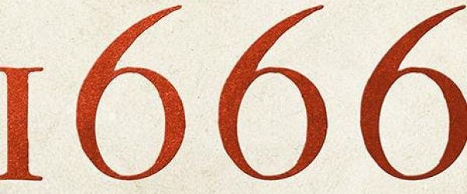

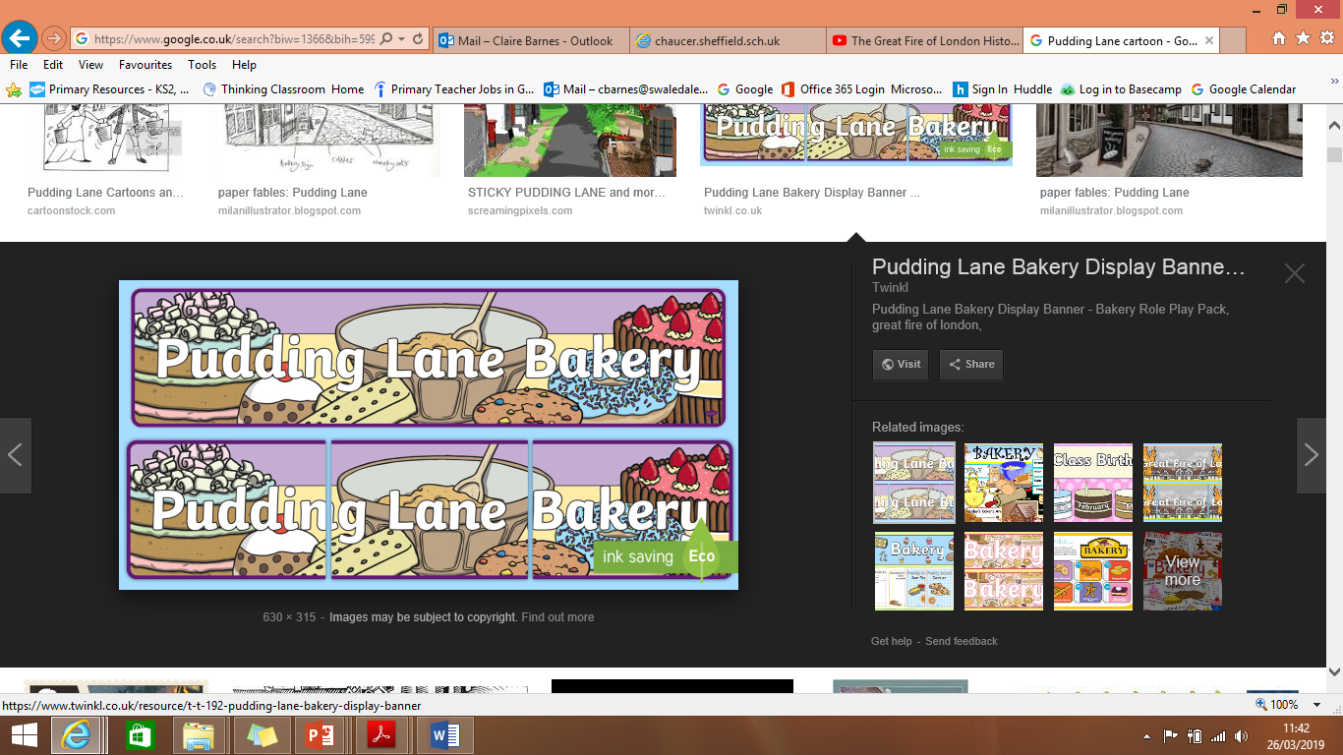

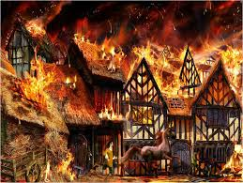

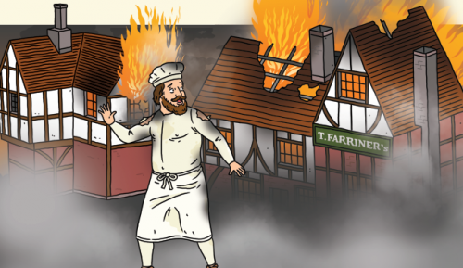

September

Morning