Impact on teachers
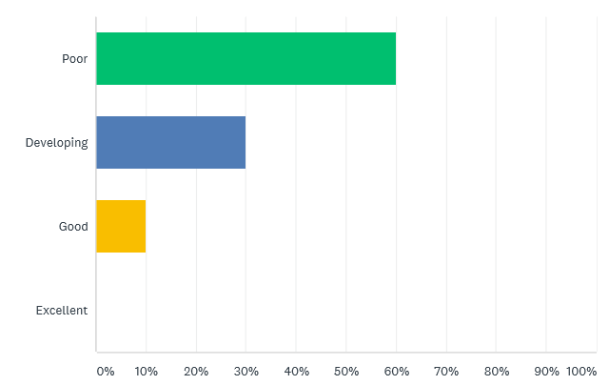
Which word best describes your understanding of metacognition before the project began? (17.7.18)

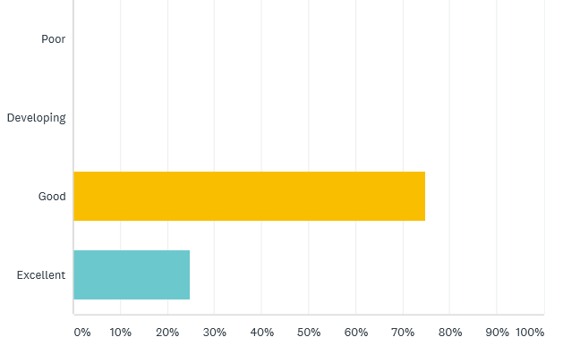
Which word best describes your understanding of metacognition? (6.12.18)

List three aspects of your practice that you have changed or adapted since the beginning of the project. (17.10.18)

‘Questioning in lessons. Giving children more time to reflect and discuss. Planning.’

‘More focused on prior knowledge of pupils and moving them forward from where they are in their learning rather than assuming a point to start from. Giving pupils a chance to verbalise their ideas/ methods used etc. More discussion!’

‘Tasks given, explicit discussion about how we have learned, more open questioning.’

What impact is metacognition having in Maths? (6.12.18)

‘Children are more engaged, more inquisitive and taking charge of their own learning and more are becoming able to then help others who may be struggling. The children who have been doing this longer, are more resilient learners.’

‘Teachers are enjoying it and the children feel very positive about maths. They are also gaining confidence when reflecting on their work.’

‘Improved independence when problem solving.’

‘Children making lots of connections - prior knowledge activation’

‘Allowing children to become more aware of their own learning and developing strategies for thinking.’

‘Positive outcome on pupils’ attitudes towards learning.’

‘Children are drawing on previous knowledge and are able to verbalise their reasoning using appropriate language.’

Evidence gathered from Surveys carried out in Lead Teachers’ Network meetings.

How has your teaching practice evolved as a result of the SSIF Project?

‘The SSIF Project has helped me to be more confident and excited about teaching. I have seen how children respond and grow and the impact it has on their attitudes and learning. It’s also impacted other staff from the training I’ve delivered. Seeing how enthusiastic they are and having them come to me for advice has made me feel really positive about going forward.’

‘I do a lot less talking. My questioning is more open ended so children of ALL abilities feel able to contribute. I facilitate and take a step back, let the children lead and enquire.’

‘Developing a metacognitive approach has had a hugely positive impact on my teaching as I now plan differently by choosing the activity first rather than learning objective, giving more purpose to their learning.’

‘I have more confidence in my own abilities and enjoy the open and interesting discussions that now develop during teaching and learning. My lessons are more pupil focused and I am more explicit during the modelling stage of my lessons.’

‘I have developed a deeper understanding of the stage of learning each pupil has reached. I encourage children to share’ discuss their ideas/ strategies more in class and I no longer assume I know what they know or should know. I feel I have a much better understanding of teaching and learning.’

‘I am using more metacognitive talk with my class, which is having a very positive impact upon their learning. Children are more confident to explain their understanding with other. Children are better equipped to take on new challenges and cope better when faced with mistakes.’ – ‘Not mistakes – learning points’ (pupils in Year 1 /2)

‘My practice has become much more child-led and open-ended. I give more my consideration to the type of questions I pose to children. I now really appreciate the importance of providing challenges and opportunities for allowing children to engage in constructive talk. We effectively activate pupils’ prior knowledge and have more open-ended tasks with time to reflect throughout a lesson.’

‘My practice has become much more child focused, with an emphasis on open-ended questioning. This has enabled the children to develop an awareness of their own learning and is helping very young learners to become more competent in talking about their learning. So although the project initially focused on maths, it has also had a massive impact on how children are formulating and expressing their thoughts.’

‘One area that has really changed is the use of more challenging questions. This has helped to develop the children’s partner talk and increased awareness of vocabulary and has helped them to identify what they already know, what they need to learn and which strategies they could use.’

‘The SIIF Project has massively impacted on my teaching. It has changed my approach and the learning in my class in now very much child-led. I know the questions I now ask in lessons helps pupils to develop their thinking. There are able to think in a structured way. I am a much more confident practitioner using a metacognitive approach in maths and all other areas of the curriculum.’

‘My classroom environment is purposeful and happy. The impact this project has had on my teaching practice and the children’s’ engagement and learning has been phenomenal.’

Evidence gathered during final Lead Teachers’ Network meeting (25.3.19)
Impact on pupils
What impact has using a metacognitive approach had on your pupils?

‘Children are more excited about learning. More focused discussions. More children are on task when working independently or collaboratively. Children are better able to help themselves and others. Children are able to identify what resources or strategies will help them and show greater confidence when selecting methods which they prefer when carrying out tasks.’
Evidence gathered during SSIF Metacognition Project filming (13.2.19)

What impact is metacognition having in Maths?

‘Children are more engaged, more inquisitive and taking charge of their own learning and more are becoming able to then help others who may be struggling. The children who have been doing this longer, are more resilient learners.’

‘Teachers are enjoying it and the children feel very positive about maths. They are also gaining confidence when reflecting on their work.’

‘Improved independence when problem solving.’

‘Children making lots of connections - prior knowledge activation.’
‘Allowing children to become more aware of their own learning and developing strategies for thinking.’
‘Positive outcome on pupils’ attitudes towards learning.’

‘Children are drawing on previous knowledge and are able to verbalise their reasoning using appropriate language.’
Evidence gathered during final Lead Teachers’ Network meeting (6.12.18)

Evidence from pupils to demonstrate a change in learning behaviour.

What do you do in lessons that makes you enjoy learning most?
‘I know that I like it when my teacher lets me work with practical resources.’

‘I like prompts to help me explain or write about my learning.’

‘I like using things to help me when learning, e.g. counting on number lines.’

‘Thinking differently than everyone else.’

‘I find out new things and it makes me feel more active and I can use that in the future. Learning what I already know in case it helps me to remember.’

‘Sometimes when we work in partners as I don’t always have a lot of ideas and my friends might.’

‘Lessons where you use your imagination, your mind leads, it’s more fun.’

‘When teacher doesn’t tell us what to do, she shows us. When teacher explores things parts at a time.’

‘I like being able to make choices and when tasks are open. I like having some freedom.’

‘I like working in pairs.’

‘I like writing things down. Sometimes, if I don’t practice, I find things hard.’

If you get stuck, what do you do?

‘I can use a ruler if I’m stuck when adding.’

‘If it is tricky, draw a picky, e.g. draw dots for 7 + 5.’

‘I now use SNOT if I am stuck – ‘self, neighbour, other and teacher.’

‘I don’t give up! I can ask a friend, work with the teacher or just keep trying myself.’

‘I learn best when I talk about my ideas with my talk partner.’

‘I use methods I know.’
‘Take a closer look, don’t try to over complicate, ask a friend for help, ask a teacher but they should explain without telling me the answer.’

‘Use counters, straws, things to help me. I’d ask someone else to help me and see if we can do it together.’

‘Use the maths working wall or learning ladder.’

‘Get some scrap paper and unpick the problem to see if makes more sense.’

‘Mistakes are good; I am just learning.’

If you had to choose a task in a lesson, would you choose the easiest task, the middle task or the challenging task?

‘I would choose the hard task now because I can try it!’

‘Hard task because you can be like Raj!’

‘I feel confident to try things.’

‘Middle – because if it’s easy, it’s not challenging but if it’s too hard, it might be annoying for myself and I’d keep putting my hand up.’

‘Challenging – I like to challenge myself and do the best I can do. If I find it hard, I can ask for help and if I still can’t do it, I could go to the medium task.’

‘Probably medium one because it might have some easier and harder parts. Because I know I like to finishing, it’s ok to have harder challenges because I know if I try and try, I’ll get it.’

‘Challenging task because there’s no point in school unless you’re learning – if it’s easy you obviously know what the answer is already and you won’t learn.’

‘Easy because I struggle with most of the work.’

Evidence taken from Pupil Learner Questionnaires (February, 2019)

Impact on pupil attainment
Data from some schools at the start of the project illustrated a rapid rate of progress since a metacognitive approach to teaching mathematics was adopted. Data collect was from ‘end of key stage’ assessments (Y2/ Y6).

KS1
School A

Paper A was an arithmetic assessment

Paper B was a
reasoning assessment

KS2
School B

Paper 1 was an
arithmetic assessment

School B
KS2

Paper 2 was a
reasoning assessment

White Rose Reasoning Assessments

In September 2018, Lead Teachers tested pupils in their classes using a reasoning paper from White Rose reasoning assessments (autumn term). Pupils were then involved in a ‘metacognitive approach during the autumn term. At the start of the spring term, in February 2019 pupils were tested again using the same reasoning paper. All data was collated and analysed. This data was given to Lead Teachers at the final Lead Teachers’ Network meeting for project files.
An analysis of the data was completed by Lead Practitioners. We identified that there was a commonality in increased data for pupils in Year 4.
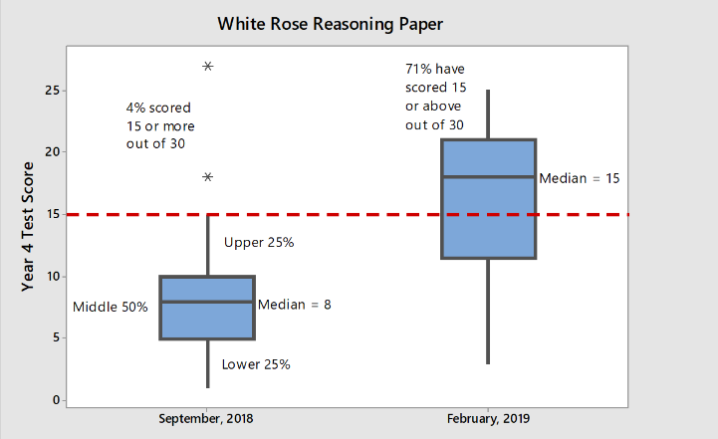
In all presentations of data, it is impossible to categorically conclude that the increase in results is a direct result of implementing a metacognitive approach. However, with such an increase in progress, a metacognitive approach is certainly a contributing factor.

