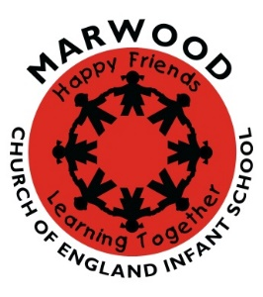
Learning Activities at Home Year 2
Reading
- Online reading books – join Oxford Owl, Education City have reading activities, especially related to comprehension.
- Keep a reading journal – which has been your favourite book to read and why?
- Write a book recommendation for the class.
- Read the information on the Ryedale folk Museum website about homes in the past
- Learn a poem by heart, write it out, perform it!
- Research about an amazing exotic animal from each of these groups; mammal, reptile, amphibian, fish and insect in its own habitat and make a fact sheet with some labelled illustrations
- Make a ‘Fact of the Day’ box after some interesting research
- Read about some famous male and female inventors and their inventions

Maths
- Education city games relating to problem solving, time and statistics – look at the learn screens for clarification and try an online test or two!
- Look at previous Year 2 set homework since September – can you beat your scores?
- Count forwards/ backwards in 2,3,4,5 and 10.
- Learn as many times tables as you can!
- Play board games and cards where children need to add and subtract totals
- Shops – ask children to ‘buy’ items with real money and pay for them in different ways. Can they give change from £1, £5, £10?
- Join Sumdog for some online maths competitions with your friends (Parent account is free)

Writing
- Keep a journal every day, include poems, feelings, diary entries, stories, explanations, recipes, letters to friends/family/teachers
- Write a leaflet about homes in the past using the information from Ryedale Folk Museum website
Art
- Try to sketch some still life objects around your home. Focus on perspective, shading techniques, shapes and outlines
- Paint a view from one of your windows
PE
- Enjoy the Cosmic Yoga sessions with an adult on YouTube
- Practise throwing and catching in different ways with different types of balls
- Practise your running technique if you have the space – can you work out how to run a mile in your own space?
- Perfect the 4/5 types of roll that we are using in our sequences in gymnastics
- Practise some different types of balances to strengthen your core
Get Ahead!
Our next topic is Excellent Explorers and we will be studying Captain James Cook and his links in the village. We will be also comparing and contrasting his explorations with those of another explorer Neil Armstrong (astronaut).
There will be a strong focus on the human and physical geography of Great Ayton – use Google maps and Google Earth to explore. Ask your child to draw a plan of the village with all the important human and physical places marked – use a key!

