I **know** that the = symbol means ‘same as’.

**Do I need things to help me?** *Fraction wall, multiplication facts?*

Working Metacognitively

I **can see** fractions.

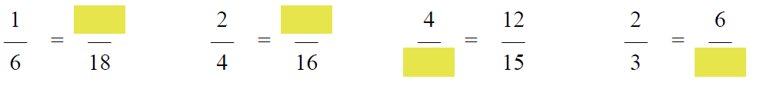

I **remember** ‘whatever you do to the top, you do to the bottom’.

I **notice** that 6 and 18 are both multiples of 6.

I could **think** about the relationship between the numerators and denominators. **What do I notice?**

Does my answer look right? Does it make sense … 4/5 = 12/15?

Could I use a model to check my answer?

reflection

Is this different or similar to the problems I saw earlier?

I **wonder** whether I can use the same method as before?

In the last task, I **needed to** find the missing numerator, now I’ve **realised** the denominator is missing.



I **could check** using multiplication facts, e.g. 5 x 3 = 15 and 4 x 3 is 12.

I **notice** that the missing part is in the first fraction, so I will need to divide because the denominator will be smaller than 15.

It was tricky when I had to use division facts.

To find equivalent fractions it helps to know times tables facts.

I prefer to use multiplication facts.

reflection